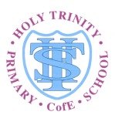
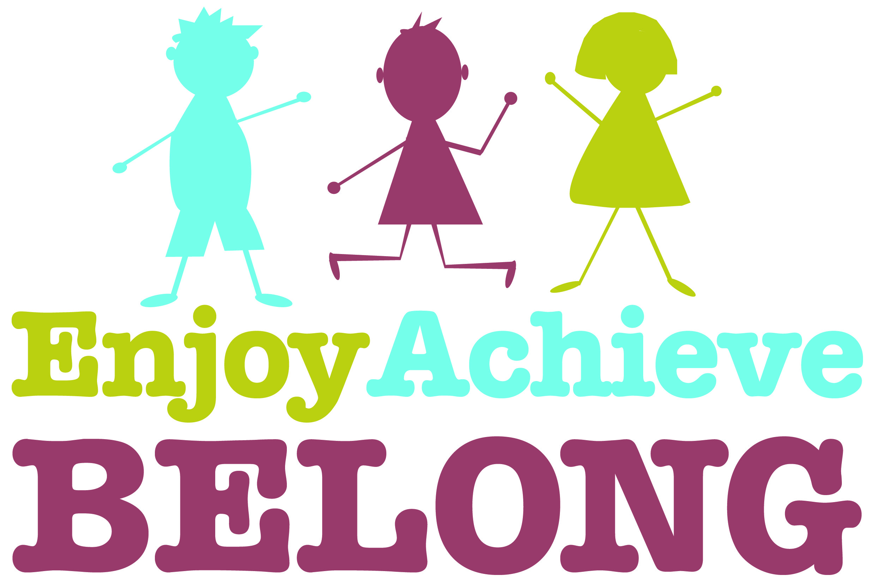
Holy Trinity Primary School Spiritual, Moral, Social and Cultural Overview
Summer Term
Topic | Reception | Year 1 | Year 2 | Year 3 | Year 4 | Year 5 | Year 6 | Whole School approaches
Topic | Topics and themes led by interests of the children | Beware of the Rocks | Beware of the Rocks | From Stone Age to Iron Age | Brazil | Born Free | Great Explorers & mountains | Whole School approaches
SMSC link  Spiritual (Sp)  Moral (M) Social (S)  Cultural (C) | Literacy  Writing their own rules (M)  Think about behaviour changes in Year 1 (S)  Read stories about change  PSHE  Healthier lifestyles: keeping safe, learning about growing and changing, what makes us healthy? (Sp)  Discussing feelings, behaviour and relationships (M)  CL learning words in other languages (S)  Communicating with other settings (M)  Circle Time  Understanding how democracy words and that your choice might not win (voting on stories to read). (C)  UW  Learning about other countries and their cultures. (C)  RE – Summer 1  What places are special and why?  Talk about somewhere that is special to themselves, saying why.  Begin to recognize that for Christians, Muslims and Jews, these special places link to their beliefs about God. (Sp / C)  RE – Summer 2  What times and stories are special?  Talk about some religious stories.  Recognise some religious words, e.g. about God  (C / Sp) | English  Story of Grace Darling (C / M)  PSHE/Science growing, changing, about ourselves, similarities/  Differences, the wonder of nature (S / Sp)  Topic  Looking at lighthouses around the country / world (C)  Circle Time – discussion on the values of forgiveness and truthfulness , school rules (S / M / Sp)  PE  Participating in sporting activities, through a key stage Sports' Day (S / M / C)  Forest School (ongoing throughout year) - Participate, volunteer and cooperate; resolve conflict; listen to others ideas (democracy) (S)  RE  Unit 1.2 Who do Christians say made the world?  Recognise that ‘Creation’ is the beginning of the Big story of the Bible (Sp)  How do Christians say thank you to God (Sp / M / S)  Unit 1.9 How should we care for the world and for others? (Sp / M / C / S) | PE Participating in sporting activities, through a key stage Sports' Day (S / M / C)  PSHE Appreciating the viewpoints of others through collaborative work on building a working lighthouse. (M)  History Learning about the impact of lighthouses on seaside communities (C)  Art Use of imagination through art work linked to the work of Edward Hopper (Sp)  PSHE Knowing what is right / wrong and be able to apply to own life (M)  Understanding the importance of team work (S)  Understanding the need for rules (C)  Recognising physical changes (Sp)  Understanding the word 'private' and its implications to us all (M)  Understanding the importance of appropriate / inappropriate touch (S / M)  Learning to make choices and beginning to understand and respect the democratic process (C)  RE Unit 1.4 What is the ‘good news’ Christians believe Jesus brings? Understand that gospel means good news (Sp / M)  Understand what prayer and forgiveness means (Sp / M / C / S)  Unit 1.8 What makes some places sacred to believers? Identifying special religious places e.g. Church, synagogue and special non-religious places (Sp / C / S) | English  Information writing on Stonehenge (C / Sp)  Exploring the life of Stone Age people through story writing using the text ‘Stone Age Boy’ (C)  PSHCE  How my body works and change, the importance of Sleep, Relationships (S / M)  PE  Developing techniques in athletics and co-operating in team games (S)  Topic  How people survived throughout the Stone, Bronze and Iron Periods – the changes over time and the advance in human skills (Sp / M / C / S)  Values Week  looking at the Fundamental British Values and what they mean to us (Sp / M / S / C + FBV)  Exploring the UK through traditions, history, food, landmarks, people, our own experiences (C / S / Sp)  RE  Unit L2.4 What kind of world did Jesus want?  Unit L2.12 How and  why do people try to make the world a better place?  Look at Bible stories to find out how Jesus wants people to be treated e.g. disciples, lepers (Sp / M / C / S)  Find out how Christian charities show compassion e.g. Leprosy Mission, Salvation Army (S) | Geography  Share information about the people and culture of Brazil (S / C)  English  Persuasive writing about saving the rainforest. (S / M / C)  Geography  Recognising the dangers of a changing environment. (M / S / C)  D and T  Cooking Brazilian food (S / C)  Geography  Why do places change? (S / C / M)  Why should environments be protected? (Sp / M / C / S)  Music  Listen to music inspired by Brazil (C / Sp)  RE  Find out about how Christian and Jewish believers follow their faith (Sp / C / S)  PSHE  Relationships and changes. (S / M / C)  Geography  Why do they cut down trees in the Amazon rainforest? (S / M / C)  Do Brazilian tribes live in the rainforest? (C / M)  Values Week  looking at the Fundamental British Values and what they mean to us (S / M / Sp / C + FBV) | English  Are zoos good or bad? (M)  PSHE / FBV  Human rights (Sp / M / C / S)  Nelson Mandela - What did he do for Africa? (Sp / M / C / S)  Born Free Foundation - Joy Adams (Sp / M / C / S)  Geography / PSHE  Looking at water issues in Africa (Sp / M / C / S)  Raise money to help those without fresh water (Sp / M / C / S)  Geography  Looking at Africa (S / C)  Marking on a map of the UK and a world map, issues that come up in the news (S / M / C)  RE  Unit U2.4 Christians and how to live  Unit 2.10 What matters most to Humanists and Christians?  Consider the beliefs and views studied and reflect on the impact of them. Make connections and add ideas of their own. (Sp / M / C / S)  Values Week  looking at the Fundamental British Values and what they mean to us (Sp / M / S / C + FBV) | Geography / History Great explorers- looking at multicultural explorers (C / S)  English Finding a voice (poetry)- looking at environmental/racial/gender/starvation/global warming (Sp / M / C / S)  English / History Shackleton's Journey- discussion of collaboration with other, reconciliation, looking at humans needs and wants (S / M)  Music Music (Roots)- singing traditional Ghana songs (C / S)  RE For Christians, what kind of king is Jesus? (M / Sp)  How does faith help people when life gets hard? (Sp / M / C / S)  Values Week  looking at the Fundamental British Values and what they mean to us (Sp / M / S / C + FBV) | Peer Mediators (S & M)  Play leaders  Science Ambassadors – volunteer, participate and cooperate (S)  Children leading the learning by writing questions they want to find out at the start of each topic. (Sp)  Class assemblies (Sp)  Launch and landing days (Sp)  School council (Sp)  Playground pals (S)  Compost kids /eco school (S)  Worship team (Sp)  Reception children paired with a Y6 ‘Buddy’ (S)  Elections (S & C)  Sports Days (Sp)  Values Week (Sp / M / S / C + FBV)  UK Elections  Church Services  Leavers’ Service  (Sp / S)  Values  Forgiveness  Truthfulness  R,Y1,Y2,Y3,Y5  Pupils are given opportunities to ask and answer Big Questions within class discussions. (Sp / M / C / S)  Pupils are encouraged to develop their spirituality through expressing their views, feelings or reflections, particularly linked to RE sessions, through art (Sp)

