
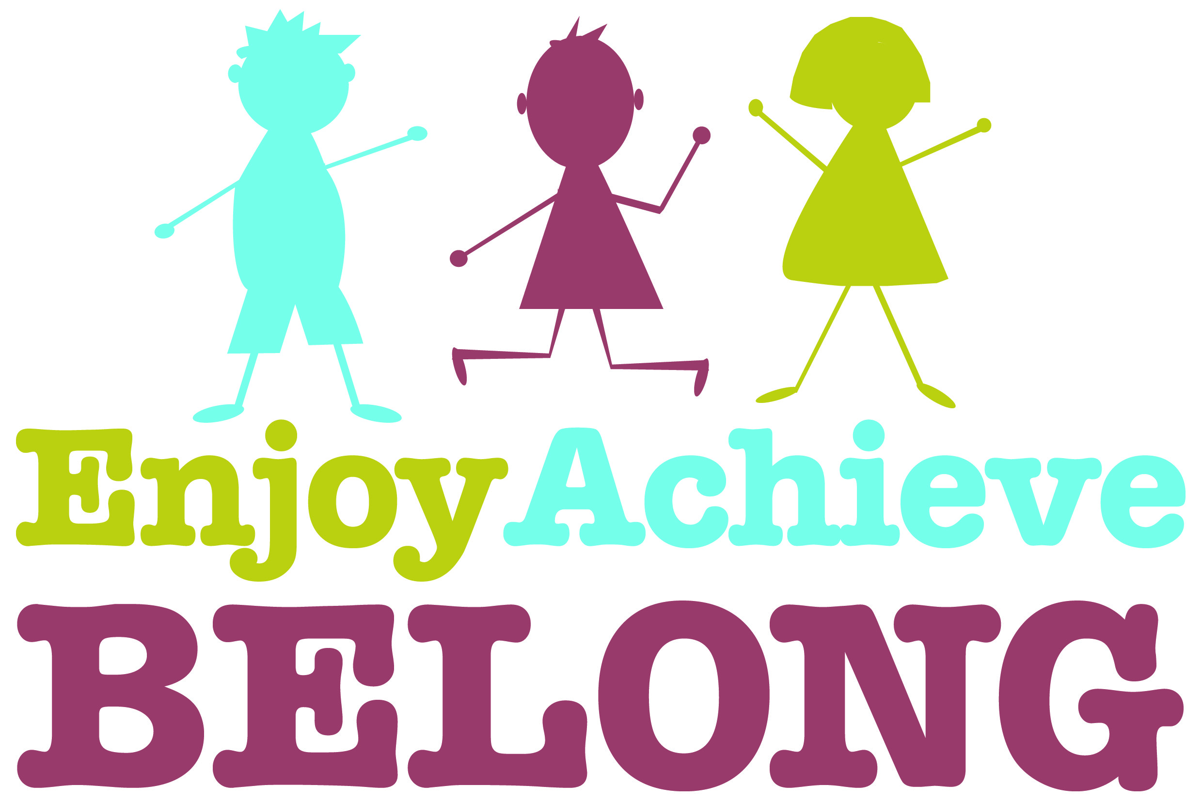
Holy Trinity Primary School Spiritual, Moral, Social and Cultural Overview
Spring Term
Topic | Reception | Year 1 | Year 2 | Year 3 | Year 4 | Year 5 | Year 6 | Whole School approaches
Topic | Topics and themes led by interests of the children | Pole to Pole | Pole to Pole | Stars and Stripes | Vikings | Eureka! | Marvellous Mayans | Whole School approaches
SMSC link  Spiritual (Sp)  Moral (M) Social (S)  Cultural (C) | Literacy  Read stories with themes of sharing, fairness and friendship.  Encourage the children to recognize how others may be feeling. (Sp / M / S)  PSED  Developing an understanding of their feelings and regulate their behaviour. (S)  Resilience (Sp)  Explain the reason for different rules (M) (Links to FBV)  Circle Time  Use traditional tales to discuss morals: Is stealing right or wrong? (Goldilocks)  Is lying right or wrong? (Little Red Riding Hood) (M)  UW  Chinese New Year  Learning about Chinese culture and celebrations (C)  Internet safety  Keeping safe online (M)  RE – Spring 1  Why is God important to Christians?  Talk about things they find interesting, puzzling or wonderful and also about their own experiences and feelings about the world / natural world. (Sp / C)  RE – Spring 2  Why is Easter important to Christians?  Recognise and retell stories connected with the celebration of Easter.  Say why Easter is a special time for Christians.  Visit to church for Easter Service. (Sp / C) | English  Talking about characters choices and feelings in Lost and Found (S / M)  PSHE  Setting Goals in our learning and how to achieve them (S / M)  All About Me! Looking at Similarities and Differences, feelings and behaviour (Sp / S)  History  learning about Edward Wilson, a significant local person from history (C)  Learning about his trip to Antarctica (C / M)  Geography Learning about Inuit people, where they live and their customs and cultures and identifying similarities and differences (S / C)  PE  Ball Skills, working with partners, working in small groups, sharing resources, taking turns, watching others (S / M)  RE  Unit 1.7 Who is Jewish and how do they live?  Find out about the Shema (Sp /S)  Explore Jewish festivals e.g. Sukkot, Shabbat, Hanukkah and Purim (Sp / C / M / S)  Learn about Esther and the mezuzah (Sp / C / M / S) | RE Develop an understanding of and participation with cultural festivals through Mothering Sunday. (C)  History Learning about British explorers and their impact on history (S)  English Developing a sense of enjoyment and fascination in the world around them through World Book Day (Sp)  Geography Learning to name the 7 continents and 5 oceans as well as locate hot and cold places on earth (C)  Learning to use simple compass directions. Learning to identify seasonal weather patterns in the UK (C)  Science Discussing the properties of both natural and man-made materials (Sp)  Thinking about living things and their habitats (Sp)  PSHE Understand that bullying can take place both on and off-line and what to do if they encounter cyberbullying (M)  Understanding that, although we all have things in common, everyone is unique (Sp)  RE  Unit 1.6 (Part 2) Who is a Muslim and how do they live?  Understand the importance of the Qur’an for a Muslim (Sp / C / M / S)  Understand the importance of prayer, respect, celebration and self-control (Sp / C / M / S)  Unit 1.5 Why does Easter matter to Christians?  Retell the Easter story and develop an understanding of the concept of Salvation (Sp / C / M / S)  Think about what Christians believe about Jesus’ death and resurrection (Sp / S / C) | English  Performing poetry and reading poetry from different poets (C / S)  Exploring Native American stories (C / Sp)  Topic  Explore the range of cultures and traditions in parts of the USA (C)  Understand the history of indigenous people living in the America (M / C)  PSHE  Linked to school Value, Compassion  Look at the work of charity RSPCA (M)  and our local environmental issues (S / M)  P.E  Learning styles of American Dance and how they originated (C / S)  RE  Unit L2.9 How do festivals and worship show what matters to a Muslim?  Submission (Sp / C / M / S)  Importance of the Qur’an and mosque (Sp / C / M / S)  Eid-ul-Fitr (Sp / C / M / S)  Unit L2.10 How do festivals and worship show what matters to Jewish people?  Rosh Hashanah and Yom Kippur (Sp / C / M / S)  What is repentance, atonement and forgiveness? (M / S / Sp)  Seder and Pesach (Sp / C / M) | PSHE  Drug awareness and personal safety (M / S / C)  English  Newspaper reports about Viking raids – different perspectives (M / S / C)  Stories from different cultures (Sp / C / M / S)  History  Vikings raids (M / S / C)  Viking customs (Sp / C / M / S)  Geography  Where did the Vikings raid? (C / S / M)  RE  Who was Jesus and why people follow him? (Sp)  Art  Viking myths (Sp / C) | PSHE  Democracy - visit the Houses of Parliament (S / M / C)  Visit skills Zones (S)  English  have a class debate on which city is better to live in (S)  Creation stories for different cultures (Sp)  History  Look at Democracy and explain that the Greeks created it? How has it changed our world? Why is it better? (C / S / M)  Greek gods and how they influenced Greek life, compared to now (Sp)  Greek laws (M / S)  Greek Philosophers and how they have changed our lives today (C / S)  Geography  Where is Greece? (C)  What are the foods from Greece? (C)  What are the economical problems in Greece (S / C)  What would it be like to be a refugee? (Sp / C / M / S)  Online Safety  (S / M)  RE  Unit U2.3 Why do Christians believe Jesus was the Messiah?  Develop an understanding of incarnation and Messiah (Sp / C)  Unit U2.9 Why is the Torah so important to Jewish people?  Explore the importance of the Torah (Sp / C / M / S)  Individual research about the Torah and synagogue  (Sp / C / M / S) | PSHE Learning about achieving and going for goals (C / M / S)  Martin Luther King (C / S / M)  Knowing difference between illegal and legal drugs (S / M)  English Writing a newspaper report and poetry, finding a voice about animal cruelty (M / S)  History Looking at Mayan religion and gods. (Sp / C / M / S)  Looking at Mayan diet. (S / C)  Seeing the Mayan calendar and the history of the Mayans. (Sp / C / M / S)  RE  Why do Hindus want to be good? (Sp / C / M / S)  What do Christians believe Jesus did to ‘save’ people? (Sp / M / S)  Art/ DT  Mayan masks and building Mayan temples (Sp / C / S)  PE Gymnastics and Dance (Sp / C / M / S) | Peer Mediators (S / M)  Play leaders  Science Ambassadors – volunteer, participate and cooperate (S)  Children leading the learning by writing questions they want to find out at the start of each topic. (Sp)  Class assemblies (Sp)  Launch and landing days (Sp)  School council (Sp)  Playground pals (S)  Compost kids /eco school (S)  Worship team (Sp)  Reception children paired with a Y6 ‘Buddy’ (S)  Church Services  Easter Service  (Sp / S)  Values  Compassion  Courage  R,Y1,Y2,Y3,Y5  Pupils are given opportunities to ask and answer Big Questions within class discussions. (Sp / C / M / S)  Pupils are encouraged to develop their spirituality through expressing their views, feelings or reflections, particularly linked to RE sessions, through art (Sp)

