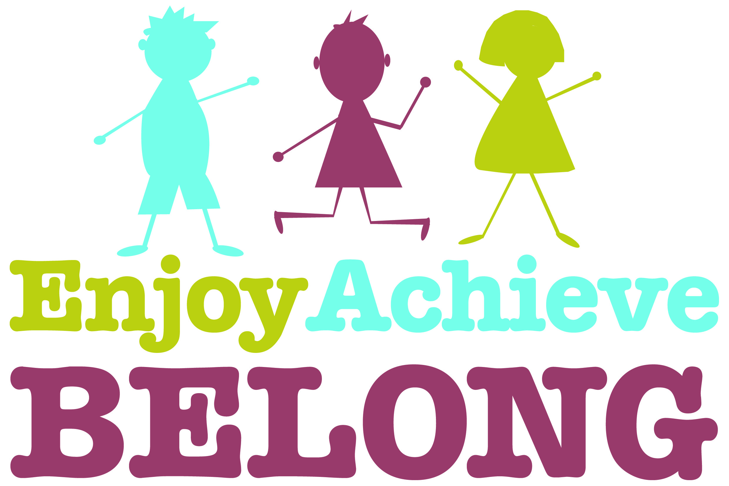**Holy Trinity Primary School Spiritual, Moral, Social and Cultural Overview**

**Autumn Term**

|  |  |  |  |  |  |  |  |  |  |  |
| --- | --- | --- | --- | --- | --- | --- | --- | --- | --- | --- |
| **Topic** | **Reception** | **Year 1** | | **Year 2** | | **Year 3** | **Year 4** | **Year 5** | **Year 6** | **Whole School approaches** |
| Topics and themes led by interests of the children | All Aboard | Russia | All Aboard | Journey to Moscow | Awesome Egyptians | Victorians | Hail Caesar! | The Great Wars |
| **SMSC link**  **Spiritual (Sp) Moral (M) Social (S)**  **Cultural (C)** | Literacy  (story time) understanding character’s feelings and choices in behaviour (S / M)  PSED  Starting School – class rules, understanding behavioural expectations, daily routines, being a good listener, working together (S / M)  Sharing life events / milestones on Tapestry, talking about home life, holiday destinations, culture and values, recognizing similarities and differences in our class (C) (Links to FBV)  Circle Time  Speaking and listening skills, working in a team, negotiating, compromise, co-operation, being a good friend (S / M)  UW  Diwali / Hanukah (C), Seasonal Changes (Sp), Black History Month (C / M)  Forest School (on-going across the year)  Learning to take turns, share resources and work together (S / M)  Looking after our environment (compost, animals, clearing rubbish) (M / C / S)  Comment on and recognize the changes in the world around us (Sp)  RE – Autumn 1  **Being Special: Where do I belong?**  Talk about the idea that each person is unique and valuable.  Talk about occasions when things have happened in their lives that made them feel special, from everyday events to special events, e.g. birthdays.  Visits to church for Harvest Festival, Christmas. (Sp / C)  RE – Autumn 2  **Why is Christmas special for Christians?**  Talk about people who are special to them.  Say what makes their family and friends special to them.  Recall, simply, what happens at a traditional Christian festival (Christmas). (Sp / C) | English understanding characters' feelings and choices in behaviour (M)  Transition to Year One rules, routines, good manners & attitudes (S / M)  Circle Time /PSHE  Speaking and listening skills, working in a team, negotiating, compromise, co-operation (S / M)  Science / PSHE  Working collaboratively to harvest pears and turn into juice at Perrygrove Railway (S / M / C)  Forest School (ongoing throughout year) participate, volunteer and cooperate; resolve conflict; listen to other ideas (democracy) (S)  RE  Unit 1.10 What does it mean to belong to a faith community?  Identify kindness in communities (Sp / M)  Understand Christian view of God’s love through Bible stories e.g. the lost sheep, the lost coin (Sp / M)  Christian infant baptism and non-religious ceremonies (S / C / M / Sp)  Discover how charities help the wider community (S / C / M / Sp) | English learning about cultural stories from Russia (C)  Dance  Peter and the Wolf (stories from other cultures, working as a class to perform movements) (S / C)  Topic learning about cultures, people including Nenet People of Northern Russia, food, religion, customs, art, special places/celebrations  (Sp / C)  Science / PSHE  Working collaboratively to harvest pears and turn into juice at Perrygrove Railway (S / M / C)  Art  using the story 'The Dot' to talk about participation and 'having a go' (S)  PSHE/Circle Time friendships, sorting out problems, relationships, valuing differences  (S / M)  RE  Unit 1.1 What do Christians believe God is like?  Explore what a parable is (e.g. the lost son) (S / Sp / C)  Understand how Christians may worship God (S / C / Sp / M)  Develop an understanding of forgiveness (M / S / Sp)  Understand what prayer is for Christians (S / Sp / M)  Develop an understanding of the concept of God from the story of Jonah (Sp / M / C / S) | PSHE  Establishing the school rule (M)  Gaining an early understanding of the democratic process (C)  English  Participation in Literature Festival (C)  PSHE  Developing awareness of emotional well-being (M)  PSHE / Computing  Focusing on working well with others through ICT - Bee Bots & Roamers - geography - working in pairs on field trip (S / M / C)  English  role play - music - working as a group to put on a performance (S)  Art  Developing imagination and creativity through art work linked to the work of William Turner (Sp)  Science  Learning about the importance of a healthy lifestyle (M)  RE  Unit 1.6 Who is Muslim and how do they live? (Part 1)  Learn about the five pillars of Islam (Sp / S / C / M)  99 names for Allah (M Sp)  How Muslims pray (S / C / Sp)  How Muslims are guided by the life of Muhammad (M / S / C / Sp) | English  Learning traditional tales from other cultures (C)  Geography  Participation in Russian supper (C)  Appreciating the need for cultural awareness and tolerance (C)  PSHE  Learning strategies to deal with unkind and bullying behaviour (S)  Discussions around friendship and development of awareness that our behaviour can have consequences (M)  Developing an awareness of the feelings of others (M)  D and T  Developing imagination and creativity through design work - designing and making a felt egg in the style of Faberge (Sp)  RE  Unit 1.3 Why does Christmas matter to Christians?  Find out about the life of Jesus (M / C / S / Sp)  Develop an understanding of incarnation (Sp / C)  Understand how the nativity story guides Christian beliefs (S / M / C / Sp)  Develop an understanding of being thankful (S / M) | History  Learning about Egypt and what life is like in Egypt today (C / M)  Learning about different Holy Books and what they mean within their religion (C / Sp)  Creating clay amulets in the style of the Ancient Egyptians (C / Sp)  PSHE  Talking about taking turns and how this affects others (S)  Talking about the qualities a good friend has and what we look for in a friend (M / S)  History / English  Visiting different places e.g. Bristol Museum, Literature Festival (S / C)  RE  Unit L2.1 What do Christians learn from the creation story?  Explore the Genesis Creation story and how Christians may respond to caring for the world (S / M / C / Sp)  Unit L2.2 What is it like for someone to follow God? Explore the story of Noah and covenant (S / M / C)  Consider the story of Abraham and the concept of faith (S / M / C / Sp) | Music  Holst’s Planet Suite (Sp)  English  Non Fiction text on Queen Victoria (M / S / C)  Historical story writing (S / M)  History  Child labour in Victorian England (S / C)  Street child (S / M / C)  Victorian schooling (S / M / C)  D and T  Design a rat catcher (S / M / C)  PSHE  Class rules  Anti Bullying  Handwashing  Media influence (S / M / C)  FBV  (S / M / C / Sp)  RE  Spiritual development (Sp)  The Trinity  Hinduism (Sp / C / M / S)  Art  Learning about Willi am Morris (S / C)  Computing  Online Safety (S / C) | PSHE  Voting for the School Council.  (C / S)  Discussing rules and right both in and outside school. (C / S / M)  English Looking at Boudicca as a leader, discuss women leaders and how over time opinions and attitudes have changed (C)  Challenge the children name some famous women leaders? (C / M)  History Discuss why the Romans invaded? (C)  What other invasions do the children know about? (C)  Think about how the Brits felt when the Romans invaded, how would you feel? (C / M)  Look at immigration, settle, and conquer. (M / C / Sp)  Discuss the Roman Soldiers and their feeling towards war? (C / M)  How do all soldiers feel about war? (C / M)  Discuss the service of soldiers, link in with Remembrance day. (C / M)  Look at the service of Roman soldiers. (C)  Geography Look at countries in Europe and discuss issues in the news concerning them (C / M)  Geography Look at countries in Europe and discuss issues in the news concerning them (S / M / C)  PE  Play invasion games with others (C / S)  RE  What does it mean for Christians to believe that God is holy and loving?  Develop an understanding of words used to describe God (Sp / M)  Weigh up Bible teachings about God (Sp / M)  Develop an understanding of the 10 Commandments and Old Testament Proverbs (Sp / C / M / S)  What does it mean to be a Muslim in Britain today?  Make connections between Muslim beliefs and Ibadah (Sp / C / M / S)  Consider the value of submission, obedience, generosity, self-control and worship in the lives of Muslims and non-Muslims today (Sp / C / M / S) | PSHE  Voting for the School Council (C / S)  Discussing rules and right in and outside of school. (C / S / M)  Managing risks and change (S / M / C)  English  Looking at Winston Churchill, Anne Frank, and Martin Luther King in autobiographical work. (C / M)  History  How the World Wars affected everyday lives. (Sp / C / M / S)    How did the war affect children and women? (Sp / C / M / S)  What were the roles of women before and after the war? (Sp / C / M / S)  What did it feel like to have rationing? (Sp / C / M / S)  Use of propaganda to encourage young men to ‘sign up’. (Sp / C / M / S)  Remembrance Day - how do we feel about this today? Why is it important? How do you think others feel about this? (Sp / C / M / S)  History / PSHE  Handling of WW1 and WW2 letters from family members and artifacts, e.g. shrapnel etc. Relations close to us, how did they feel? (S / M / C)  Art  Propaganda posters (M)  PE  Playing invasion games with others (C)  RE  Creation and science: conflicting or complementary? (S / M / Sp)  Why do some people believe in God and some people not? (S / M / C / Sp) | Peer Mediators (S / M)  Play leaders  Science Ambassadors – volunteer, participate and cooperate (S)  Children leading the learning by writing questions they want to find out at the start of each topic. (Sp)  Class assemblies (Sp)  Launch and landing days (Sp)  School council (Sp)  Playground pals (S)  Compost kids /eco school (S)  Worship team (Sp)  **Church Services**  Joining Service (R)  Harvest and Christmas  (Sp / S)  **Values**  Respect  Responsibility  R,Y1,Y2,Y3,Y5  Pupils are given opportunities to ask and answer Big Questions within class discussions. (Sp / M / S / C)  Pupils are encouraged to develop their spirituality through expressing their views, feelings or reflections, particularly linked to RE sessions, through art (Sp) |